**The Duck King of Lala**

A Tale of Magic and Mischief

Written by Aleo Amiruzzaman

Illustrated by Md and Stefanie Amiruzzaman

©2025 **Aleo Amiruzzaman.**

All rights reserved.

This is a work of fiction. Names, characters, places, and incidents are either the products of the author's imagination or are used fictitiously.

For all the young adventurers who believe in magic and adventure.

**Table of Contents**

Contents

The Duck King of Lala 6

Duck King 6

Penny’s Evil Potion 8

Meanwhile 8

Sam’s Escape Plan 10

In the Morning 10

The King Prepares for Dinner 12

Evening Plans 12

Meanwhile… 14

Penny’s Plan 16

Lunch with MT 18

The Next Day 20

About the Author 23

Aleo 23

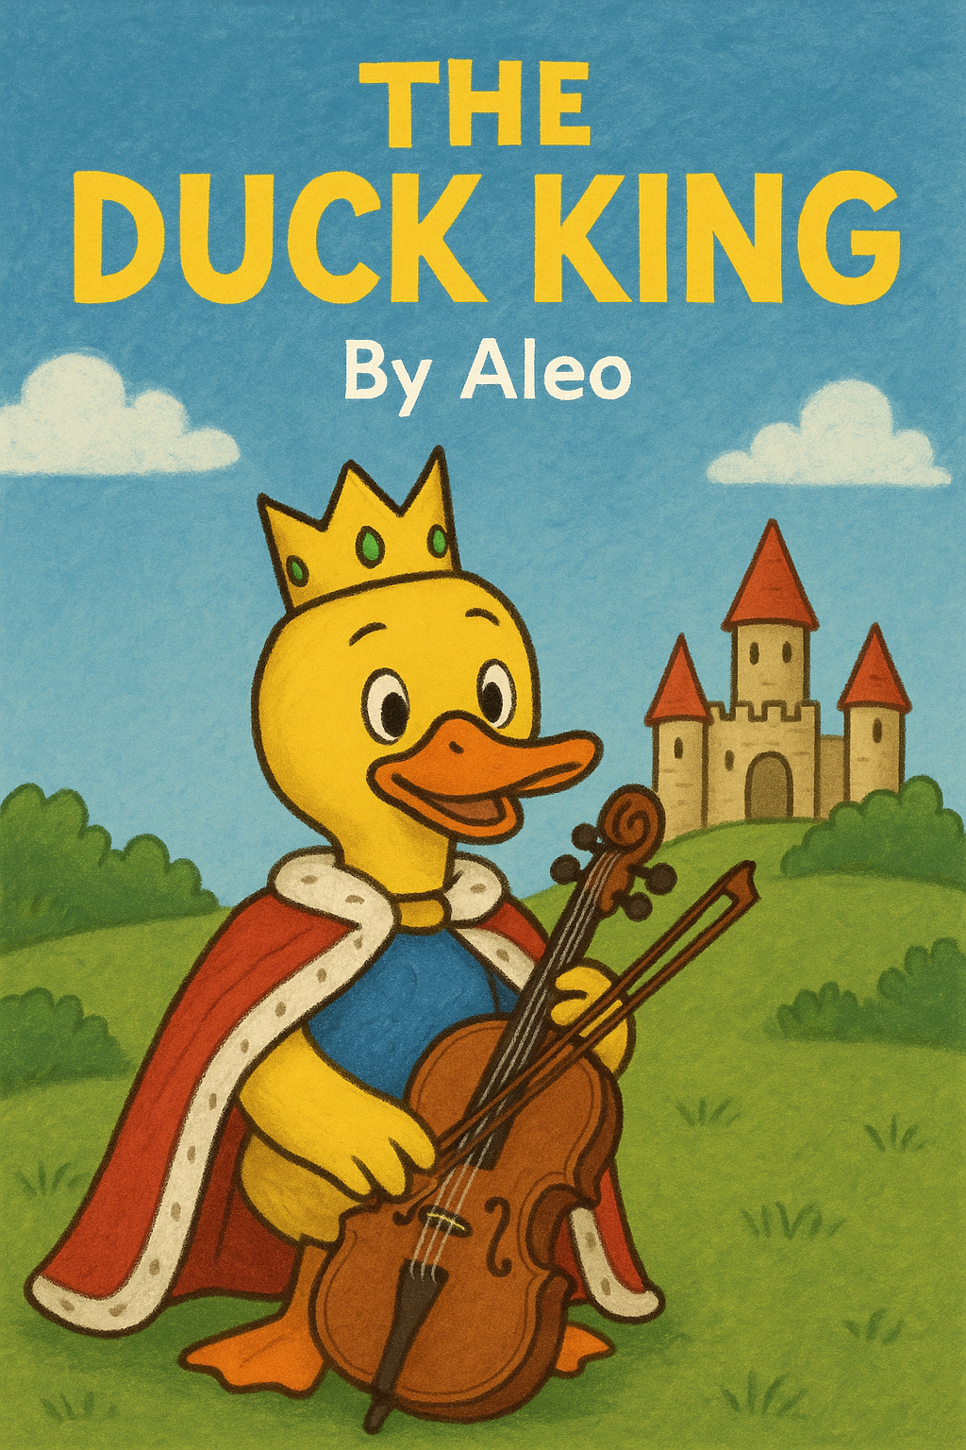

# The Duck King of Lala

## Duck King

Once upon a time, there was a king—the Duck King. He lived in the cheerful land of Lala.

One day, he went to the store. At the store, he met Penny the Chicken. The King and Penny talked for 199 hours. Afterward, the King left and went home to his castle.

He ate dinner and then played his cello. After that, he went to bed.

Early the next morning, he woke up at 4:00 a.m. to do some exercises, and then went back to sleep.

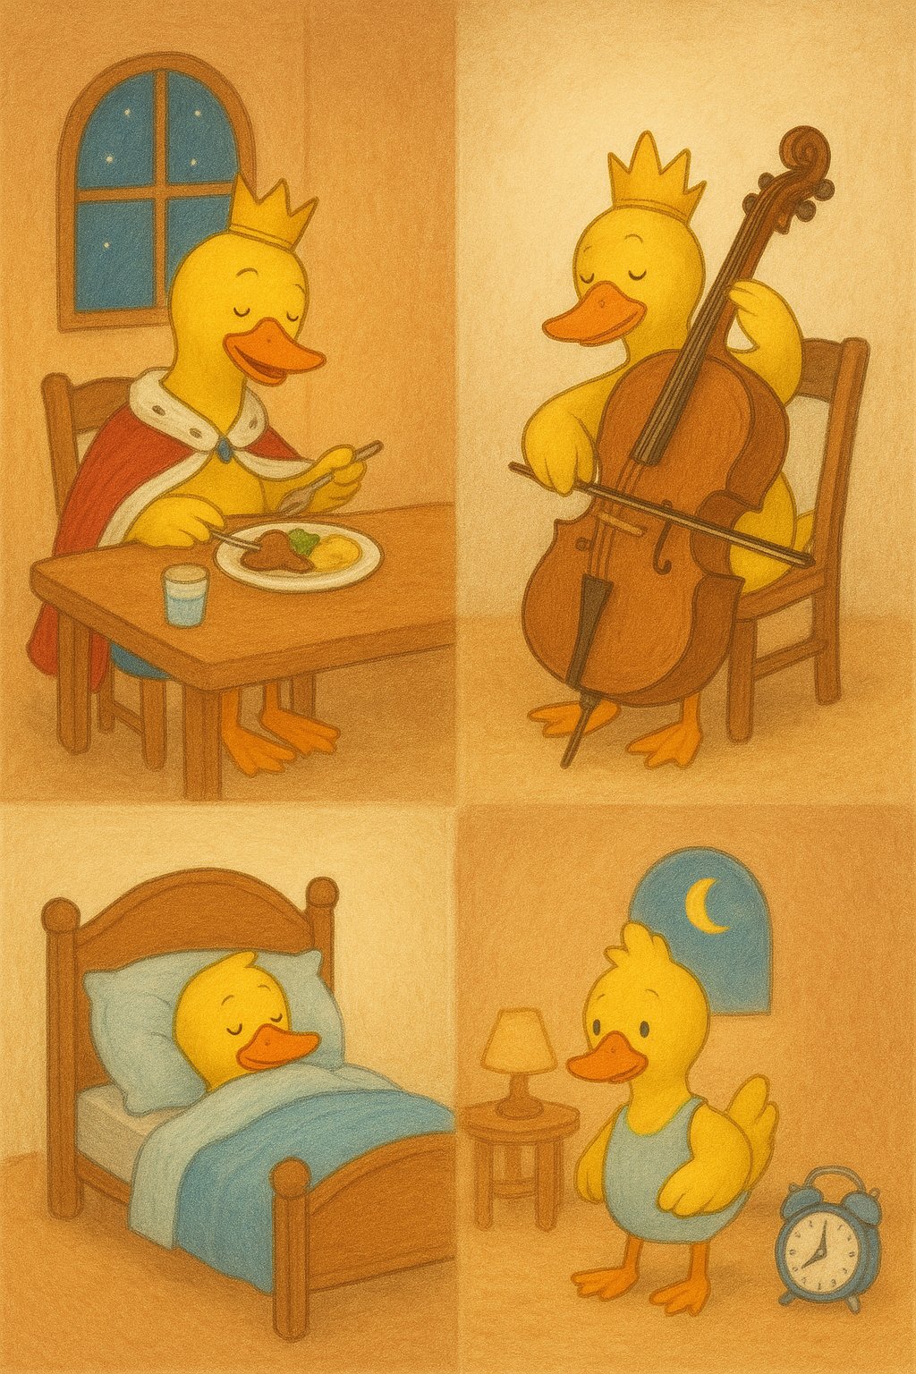

# Penny’s Evil Potion

## Meanwhile

Penny was in her science room. Her evil science room. She was making a potion. The potion was called the Past Potion.

She made the potion because she did not like the King.

This potion would send the King far into the past. And then—she would take over his job. That meant she would become an evil Queen.

Penny was happy. Very happy. Soon, the whole world would bow down to her.

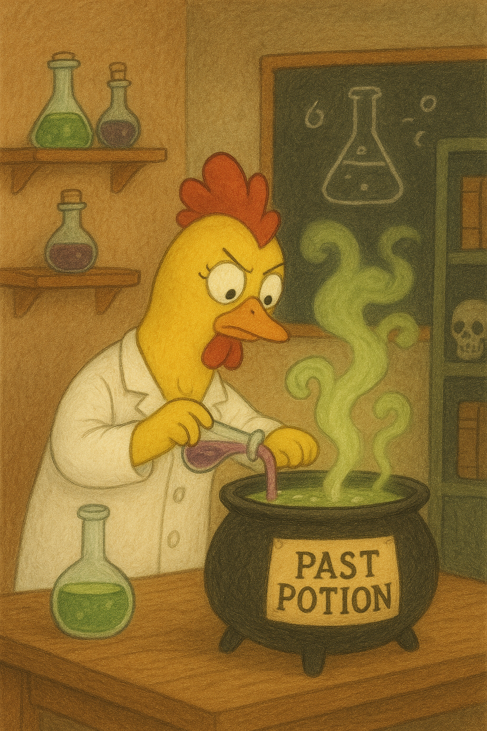

# Sam’s Escape Plan

## In the Morning

The King ate breakfast. Then he played his cello. After that, he had to work all day.

Meanwhile…

At Satmean Prison, Sam the alligator was making a plan to escape. He carefully wrote it down in his evil notebook.

In the Afternoon the King was eating lunch and talking to his friends. Suddenly, Penny came and sat next to him. She whispered to the King that she wanted him to eat dinner with her. And the King said “yes.” Penny smiled, then hurried back to her evil lab. The King finished his lunch and worked some more.

Back at the Prison, Sam the alligator finished his escape plan. And finally—he escaped from prison!

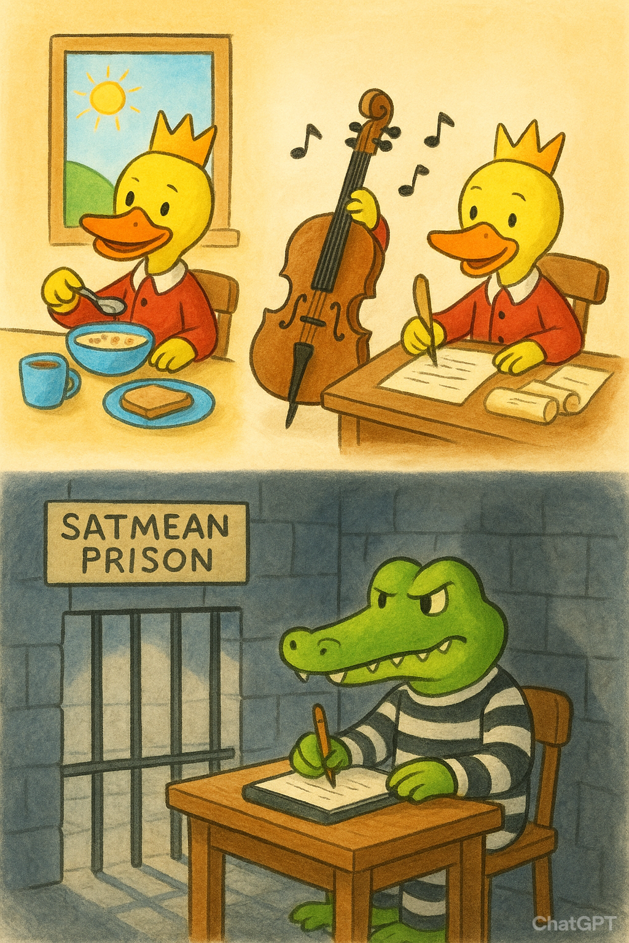

# The King Prepares for Dinner

## Evening Plans

The King finished his work and then he went home. He was excited—because Penny had invited him to dinner. He had six whole hours to do whatever he wanted.

First, he played his cello. Because playing his cello was his favorite thing to do. Then he went to Kohl’s to buy some clothes. And to Walmart to buy some food.

After all that, he still had two and a half hours left.

But there was nothing else to do. So… he watched a movie.

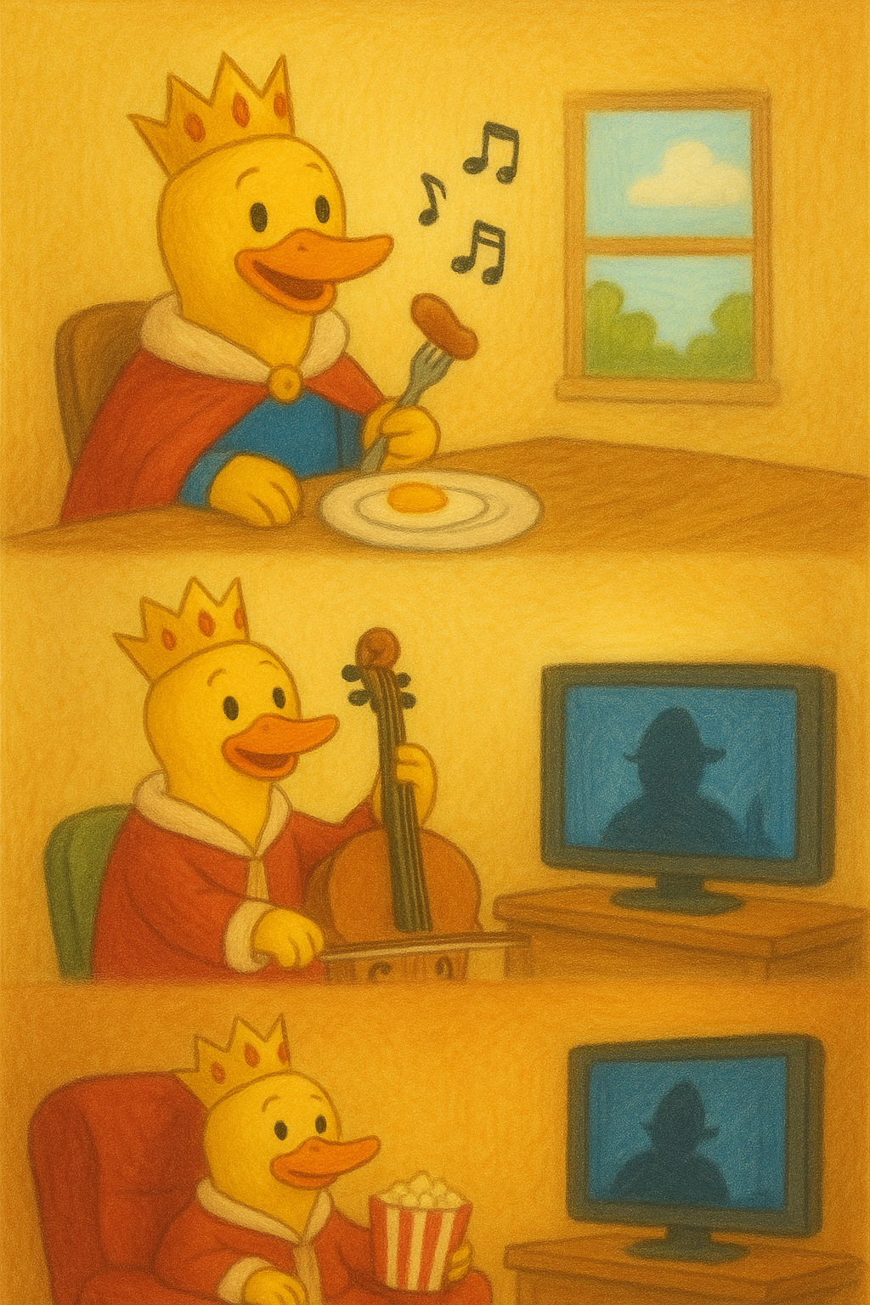  
The Dinner Trap

## Meanwhile…

Penny was preparing for the King. She added some ingredients to the potion to make it look just like water.

Meanwhile… the King finished his movie.

Then he went to his car and drove to Penny's house. It was only five minutes away.

Penny was waiting for him. When he arrived, she asked, “Do you want to eat dinner?” and the King said “yes.” He took a drink of the potion—and in an instant…he disappeared into the past!

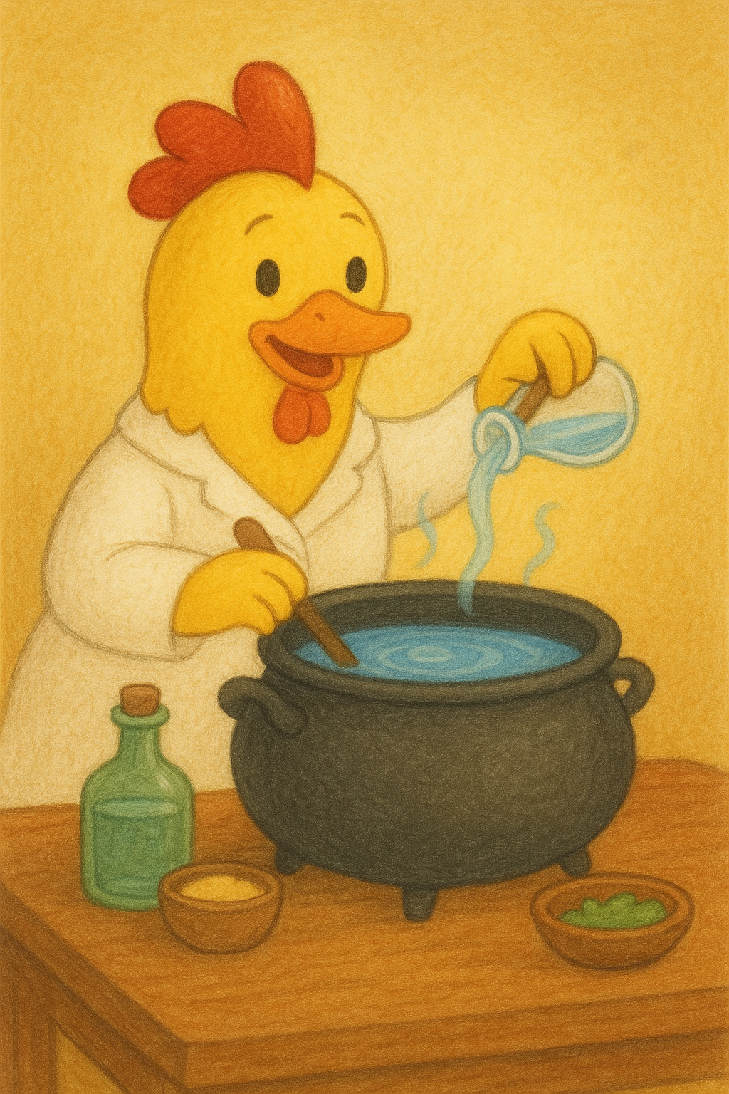  
Mama Teddy’s House

## Penny’s Plan

Penny cleaned the table. When she was done, she left her house to become the Queen.

Meanwhile… the King was in the past. He did not know what to do. He went to find shelter. He came to a house and knocked on the door. The door opened, and the King saw a blue bear named Mama Teddy (MT). But she called herself MT. The King stayed there for the night. He had to convince MT to let him stay longer. He asked her and she said “yes.”

Meanwhile… Penny was finally the evil Queen. She turned her sky black, and everyone bowed down to her.

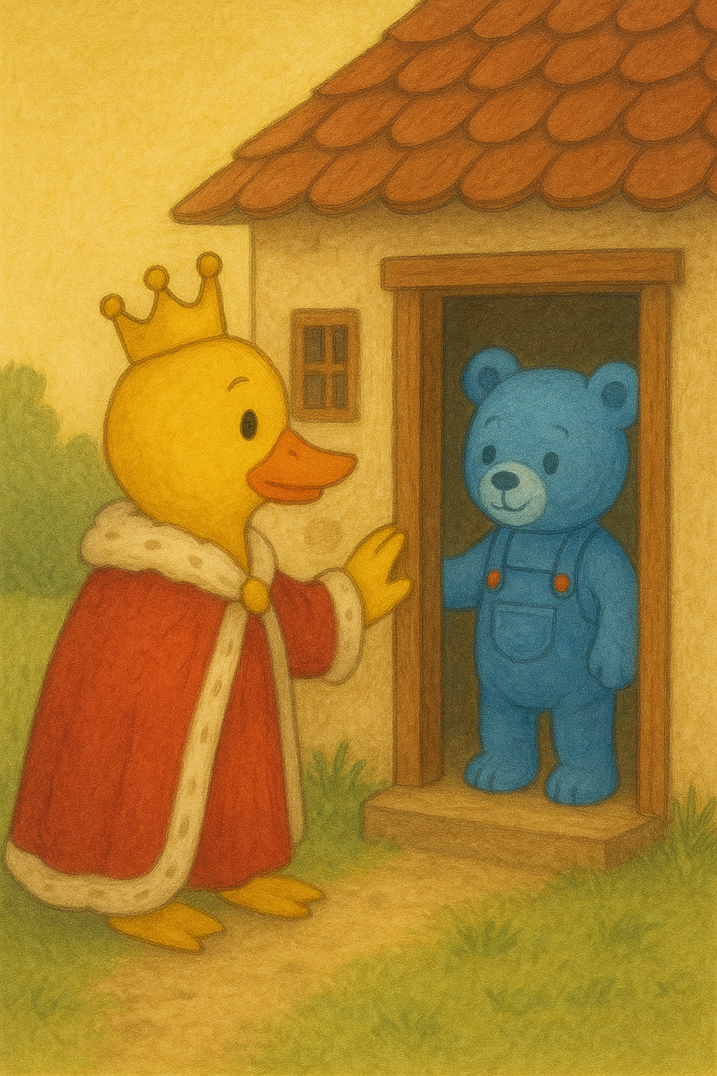  
Music in the Past

## Lunch with MT

MT made lunch for the King. She cooked spaghetti and meatballs. The King ate until his plate was clean.

After lunch, they went to the music store to buy him a new cello since his other cello was still in his own time.

MT told him that George Washington was the president, and that he was not the King here. So the Duck King thought, ”Maybe I can talk to the President…”

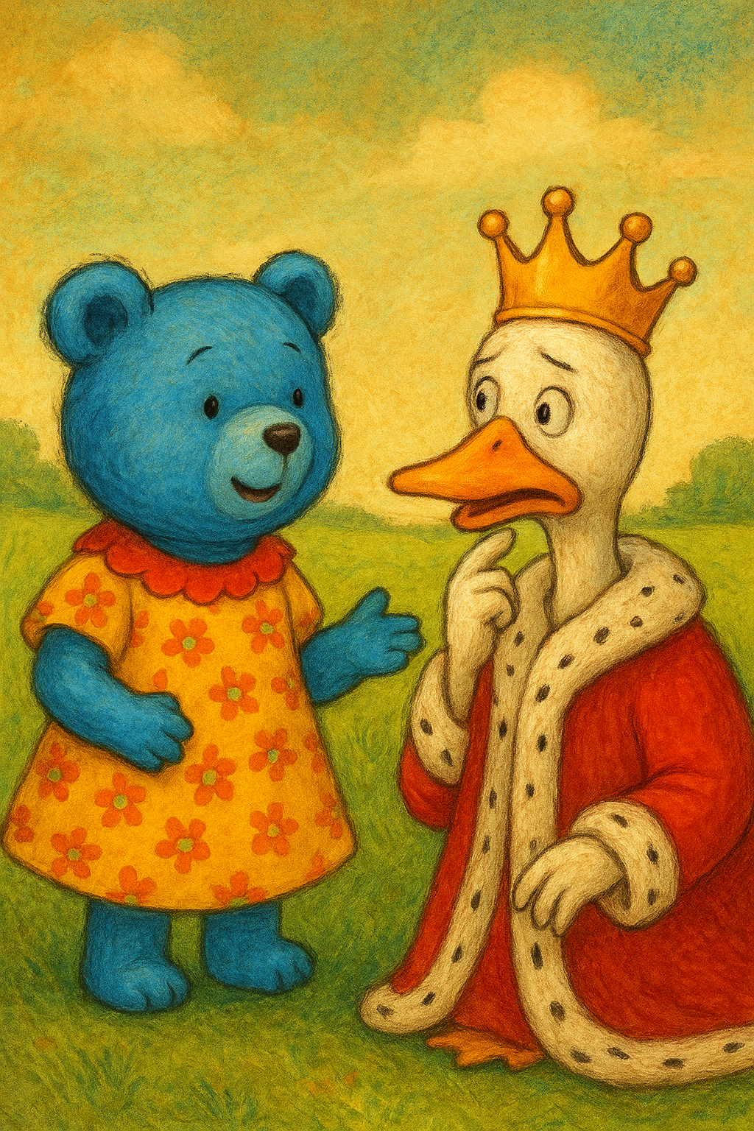  
The Ending

## The Next Day

MT and the King went to the White House. The King and the President argued, but then they stopped arguing.

The President said he would make a portal. When he made the portal, the King disappeared back into his own time—and Mama Teddy came too.

Back at the Castle, MT and the King were in the King's castle. They found a spot to hide. MT told the King that she was a magician. She said a magic word and everything was back to normal. The sky turned blue. Nobody bowed down to Penny anymore.

The cops arrested Penny and sent her to prison. They also found Sam the alligator and put him back in prison too. The King and MT lived happily ever after.

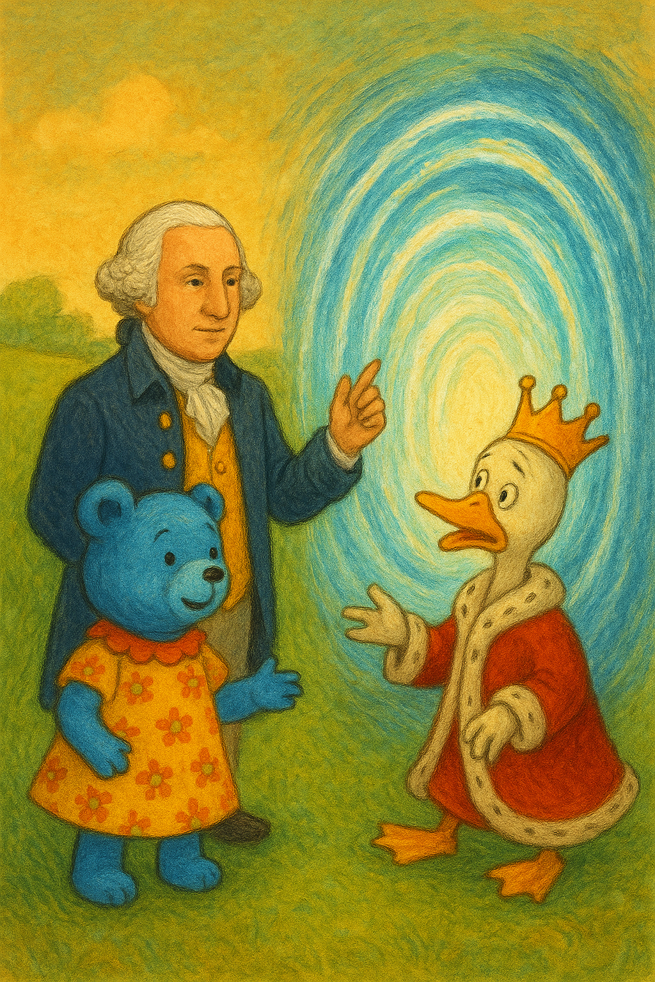

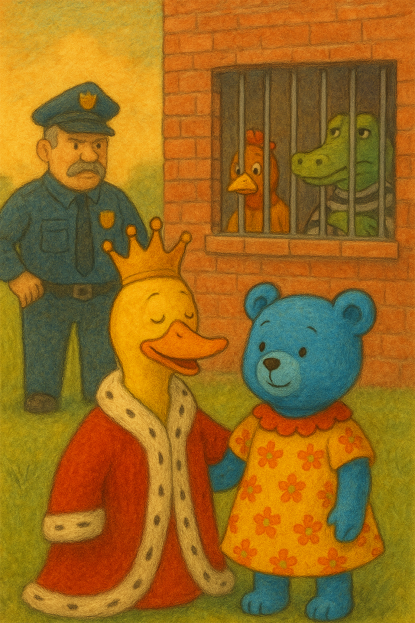

# About the Author

## Aleo

Aleo Amiruzzaman is a storyteller who loves creating tales of adventure and friendship for young readers. When he’s not writing, Aleo enjoys reading, solving math problems, and dreaming up new worlds. The Duck King of Lala is his first children's book.

Index

Aleo Amiruzzaman, 22

alligator, 9

cello, 11

Duck King, 5

escape, 9

first children's book, 22

George Washington, 17

happily, 19

Mama Teddy, 15

movie, 11

past, 13

Past Potion, 7

Penny, 5

Prison, 9

Queen, 7

spaghetti, 17

White House, 19